Technische handleiding webapp

Emptying the SQL

1. Go to phpMyAdmin
2. Go to the database webapp
3. Go to questions

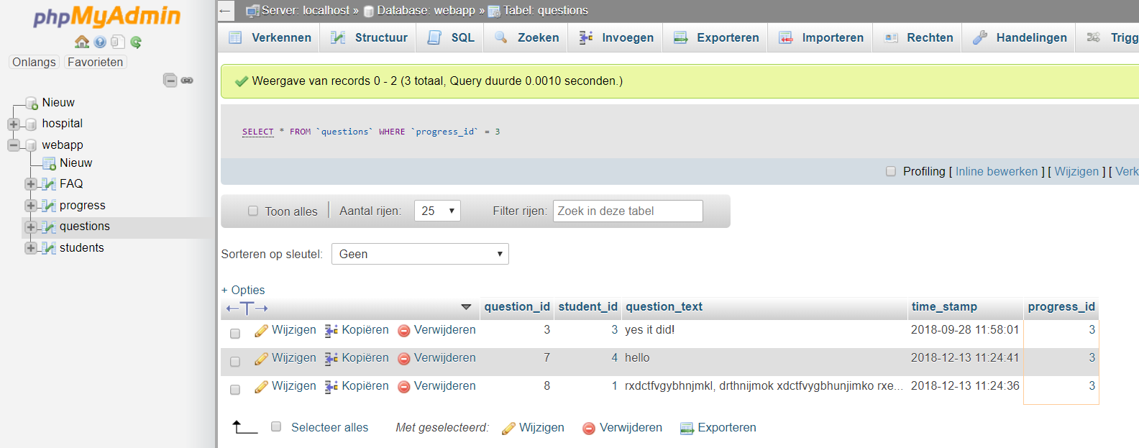

1. Select everything like this

[SELECT](http://localhost/phpmyadmin/url.php?url=http://dev.mysql.com/doc/refman/5.5/en/select.html) * FROM `questions` WHERE `progress_id` = 3

1. Click select all in the bottom
2. Click delete

There you just deleted all the already answered questions from the DB